# Lab # 12

## Objective: Assemble a half wave diode rectifier circuit and observe its input and output waveforms. Equipment:

* + Transformer (AC center-tapped, Triad F-25X or equivalent)
  + Silicon diode (1N4001 or equivalent)
  + Resistor ½ W (1kΩ)
  + VOM (Analog & Digital Multimeter)
  + Oscilloscope

## Theory

**Half-Wave Rectification:**

A diode's property of conducting current in one direction and blocking it in the other allows it to function as a rectifier, converting AC voltage into DC voltage. In this lab, we are focusing on a **half-wave rectifier**, the simplest form of rectification.

## Operation

During the positive half-cycle of the AC input, the diode becomes forward biased and conducts current through the load resistor (R), producing a voltage across R. This voltage mirrors the positive half of the AC input. During the negative half-cycle of the AC input, the diode is reverse biased, blocking current flow. As a result, no voltage is produced across R during this cycle.

The net effect is that only the positive half-cycle of the AC input appears as output. This unfiltered DC signal has a significant ripple, but it can be smoothed using filters in more advanced circuits. The average value of the output voltage can be measured with a DC voltmeter.

The ripple frequency of a half-wave rectifier equals the input frequency, and its unfiltered output has an average DC value of approximately 45% of the RMS secondary voltage of the transformer.

## Procedure

* + Assemble the circuit as shown in Fig.
  + Connect the primary side of the transformer to the AC mains and the secondary side to the rectifier input (diode and resistor).
  + Using a multimeter, measure the RMS voltage across the secondary winding of the transformer and record the value in Table.
  + Using an oscilloscope, measure and record the peak input voltage (before rectification) and note it in the Table.
  + Using the oscilloscope again, measure the peak output voltage (after rectification) and record it in Table.
  + Measure and record the DC load voltage across the 1kΩ resistor using the multimeter set to DC voltage mode.

## Circuit Diagram

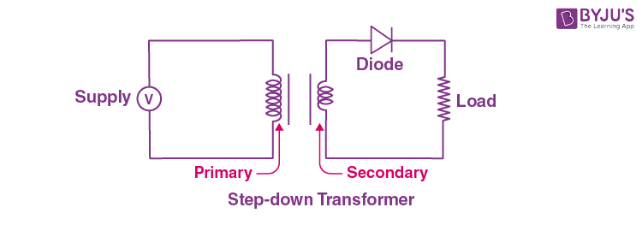

Half Wave Rectifier Circuit

## Observation Table

|  |  |  |  |
| --- | --- | --- | --- |
| **Parameters** | **Formula** | **Calculated** | **Measured** |
| **RMS secondary voltage** |  |  |  |
| **Peak input voltage** |  |  |  |
| **Peak output voltage** |  |  |  |
| **DC output voltage** |  |  |  |

**Plot the input wave and output wave:**

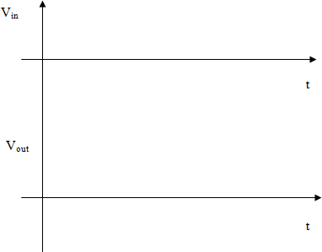

Plot the input and output waves for Half wave rectifier

## Result

The half-wave rectifier circuit successfully converted the AC input signal into a pulsating DC output. The input waveform, as observed on the oscilloscope, is sinusoidal, while the output waveform consists of only

the positive half-cycles. The average DC voltage across the load resistor is significantly lower than the peak AC input voltage due to the nature of half-wave rectification.

## Conclusion

The half-wave rectifier allows only the positive half of the AC input signal to pass through, effectively blocking the negative half. This results in a pulsating DC output with a significant ripple. The measured DC output voltage is consistent with the theoretical expectations based on the circuit design. This experiment demonstrates the basic principles of diode rectification and highlights the practical application of diodes in power supply circuits.

## Safety Precautions

* + Ensure proper insulation of the transformer to avoid electrical shock.
  + Handle the AC mains connection carefully.
  + Verify correct polarity when connecting the diode to prevent damage.

## Post Lab:

1. What happens to the output waveform if the input frequency is doubled?
2. How does the ripple frequency compare to the input frequency in a half-wave rectifier?
3. Why is the peak output voltage lower than the peak input voltage by 0.7V?